**Tutorial 2**

Ex1:

1. i

composite attribute - can be broken into component parts

1. d associative entity - relationship modeled as an entity type
2. b unary relationship - relates instances of a single entity type
3. j weak entity - depends on the existence of another entity type
4. h attribute - property of an entity

1. l entity - person, place, object, concept, event
2. e relationship type - association between entity types
3. c cardinality constraint - specifies maximum and minimum number of instances
4. g degree - number of participating entity types in relationship
5. a

identifier - uniquely identifies entity instances

1. f

entity type - collection of similar entities

1. k

ternary - relationship of degree 3

Ex2:

1. Stored attribute: values stored in the database

Derived attribute: values can be calculated from related attribute values (not physically stored in the database)

1. Simple attribute: can be broken down into smaller components

Composite attribute: that has meaningful component parts

(attributes)

1. Entity type: a collection of entities that share common properties or characteristics, Relationship type is a meaningful association between (or among) entity types.

1. Strong entity type: exists independently of other entity types Weak entity type: depends on some other entity type.

1. Degree: the number of entity types that participate in that relationship

Cardinality: constraint on the number of instances of one entity that can (or must) be associated with each instance of another entity.

1. Required attribute: have a value for each entity instance

Optional attribute: may not have a value for every entity instance.

1. Composite attribute: has component parts that give meaning Multivalued attribute: may take on or more values for an entity instance.
2. Ternary relationship: relationship of degree 3

Three binary relationships: three relationship of degree 2

Ex3:

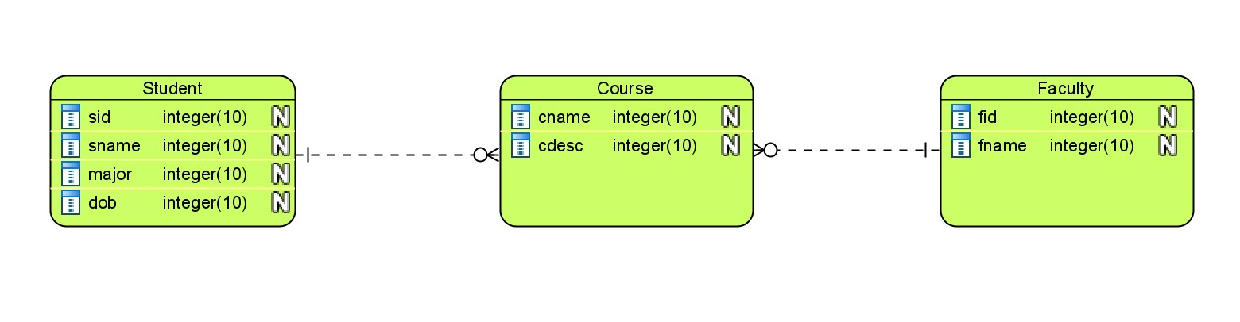

Ex4:

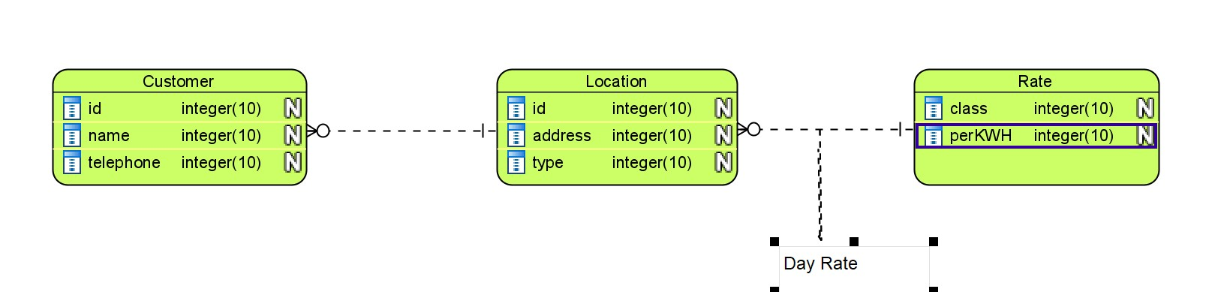

Ex5:

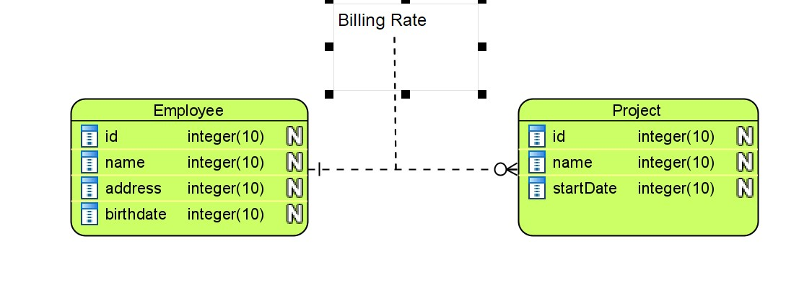

**Homework**

Ex1.

1. Entity type: Type–collection of entities
2. Entity-relationship model: is a high-level conceptual data model diagram
3. Entity instance: A single occurrence of an entity type
4. Attribute: property of an entity
5. Relationship type: a meaningful association between entity types
6. Identifier: attribute uniquely identifies individual instances of an entity type
7. Multi-valued attribute: more values for an entity instance
8. associative entity: relationship modeled as an entity type
9. cardinality constraint: instances of one entity must be associated with instance of another entity
10. weak entity: depends on the existence of another entity type
11. identifying relationship: links strong entities to weak entities
12. derived attribute: values can be calculated from related attribute values

Ex2.

a. Derived attribute: age can be derived from data_of_birth

b. Multi-valued attribute: a student can have more than one email, phone, course

c. Atomic attribute: First_name, last_name of a person, names of things etc. – a person’s name may be divided into first name, last name and middle name etc. But a person’s first name cannot be divided further to give meaningful information. Hence, a first name is an atomic attribute,

d. Composite attribute: data_of_birth may have day, month, year

e. Required attribute: In a course must have data of teacher and student

f. Optional attribute: When consider a student, data about middle name is optional

Ex3.

- Degree of a relationship is the number of entity types that participate in it

* Unary Relationship

Do research

Students

* Binary Relationship

Course

Register

Student

Course

Register

Student

Course

Register

Student

STC

Teacher

Course

Student

Course

Register

Student

Course

Register

Student

Register

Course

Student

* Ternary Relationship

STC

Student

Course

Teacher

Ex4.

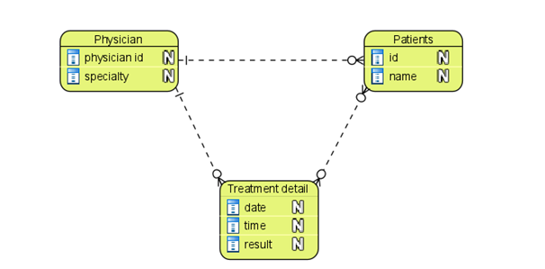

Student

Course

Teacher

STC